STAT430
Homework 4
Yizhan Ao

(Suggestion: Do a PROC PRINT to see the data, this will be very helpful to you)
CODE:
Data Homework4;
Infile '/home/u58594663/my_shared_file_links/schimiak/HW_4_Final_Exam_Work.csv' Delimiter=',' DSD;
INPUT
Final_Grade
Final_Exam
Class_Work;
RUN;
PROC PRINT DATA=Homework4;
RUN;

Obs | Final_Grade | Final_Exam | Class_Work
1 | 61.608 | 51 | 76.944
2 | 98.592 | 88 | 100.000
3 | 75.221 | 54 | 98.444
4 | 90.639 | 88 | 93.278
5 | 78.796 | 65 | 96.611
6 | 68.819 | 51 | 79.611
7 | 85.014 | 71 | 97.944
8 | 90.664 | 77 | 96.611
9 | 76.245 | 58 | 96.333
10 | 86.508 | 87 | 96.111
11 | 91.132 | 67 | 100.000
12 | 94.216 | 85 | 92.111
13 | 86.872 | 60 | 100.000
14 | 55.562 | 44 | 43.056
15 | 73.737 | 64 | 9.333
16 | 75.608 | 56 | 41.944
17 | 66.852 | 67 | 17.000
18 | 73.187 | 63 | 58.333
19 | 59.374 | 22 | 5.556
20 | 71.000 | 29 | 10.611
21 | 62.087 | 60 | 0.000
22 | 78.012 | 54 | 83.389
23 | 92.550 | 77 | 98.667
24 | 100.008 | 100 | 100.000
25 | 74.367 | 55 | 87.722
26 | 81.934 | 65 | 93.944
27 | 82.309 | 77 | 99.222
28 | 86.210 | 85 | 100.000

- Do a PROC FORMAT to change the following: Determine the letter grade (LETTER_GRADE) for the Final_Grade (10 point scale: 90-100 A, 80-
IF Final_Grade >= 90 then LETTER_GRADE = 'A';
ELSE IF Final_Grade >= 80 and Final_Grade < 90 then LETTER_GRADE = 'B';
ELSE IF Final_Grade >= 70 and Final_Grade < 80 then LETTER_GRADE = 'C';
ELSE IF Final_Grade >= 60 and Final_Grade < 70 then LETTER_GRADE = 'D';
ELSE LETTER_GRADE = 'F';

- Make a frequency chart for Letter_Grade
proc sgplot data=Wproc sgplot data=WORK.TRANSFORM;
vbar LETTER_GRADE /;
yaxis grid;
run;ORK.TRANSFORM;
vbar LETTER_GRADE /;
yaxis grid;
run;

- Create a Scatterplot of the final grade vs final exam grade.
PROC GPLOT DATA = HW4;
PLOT Final_Grade*Final_Exam;
RUN;

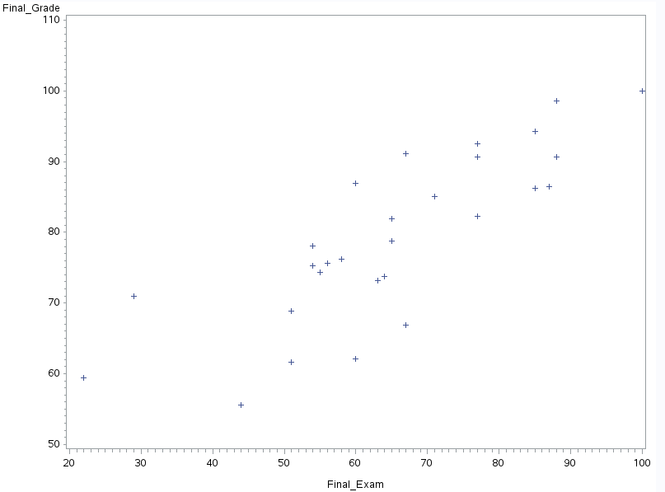

- Create a scatterplot of the final grade vs class work.
PROC GPLOT DATA = Homework4;
PLOT Final_Grade*Class_Work;
RUN;

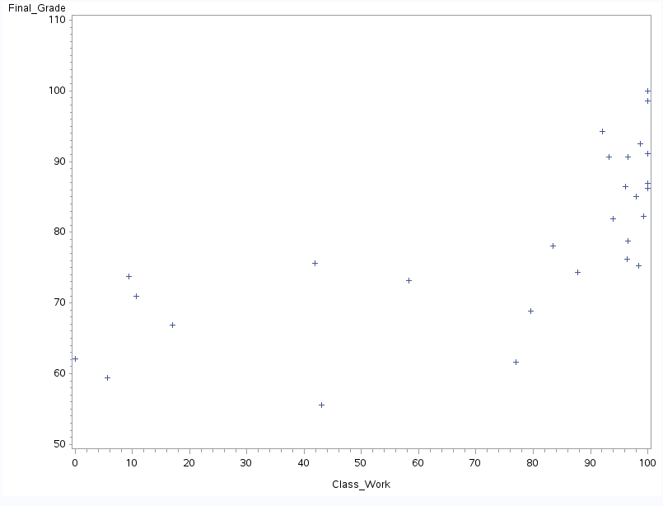
- Determine then state the Pearson Correlation Coefficient for the following:
  - final grade and final exam
/* */
PROC CORR DATA = Homework4;
VAR Final_Grade Final_Exam;
RUN;

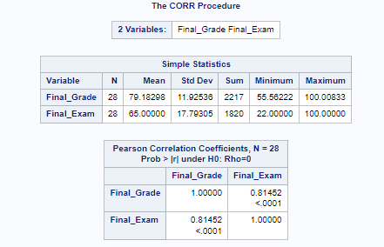

Based on Pearson Correlation coefficient of the final grade and final exam is 0.81452
  - final grade and class work

PROC CORR DATA = Homework4;
VAR Final_Grade Class_Work;
RUN;

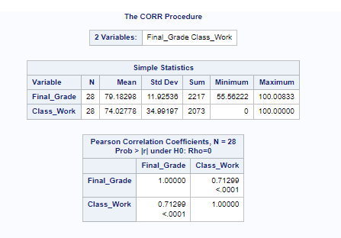

Based on Pearson Correlation coefficient of the final grade and final exam is 0.71299.
- Do a regression on the following:
  - Predict final grade based on final exam grade
PROC REG DATA = Homework4 PLOTS = DIAGNOSTICS(STATS = NONE);
MODEL Final_Grade = Final_Exam;
RUN;

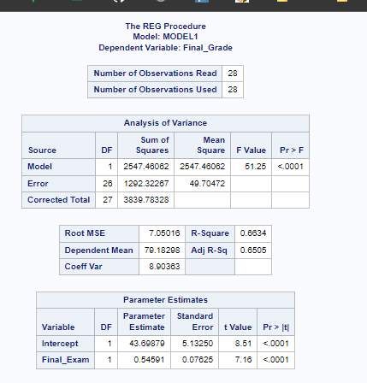
I Speak to meaning and implication of the following:
- P-value of ANOVA table
  - P value is <0.0001 given 95% confidence level, the p value is less than 0.001 and the difference is small meaning the data is statistically important. So the data model is good here
- P-value of the slope and intercept
  - The P-value of slope is < 0.0001,
  - given 95% confidence level, the p value slope is less than 0.001 , and the slope of intercept are <0.0001 which means the intercept and the slope are statistically important
- R 2 value
  - The R^2 value is 0.6634
  - The coefficient of determination (R2) expresses how much variance in one variable can be explained by the variance in another. The R2 value is 0.6634, which suggests that x accounts for 66.34 percent of the variation in the y variable (final grade).
- Residual Analysis
  - Fit vs Residuals
    - 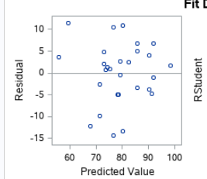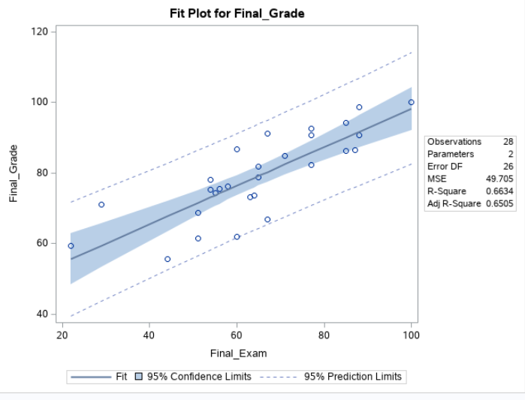
    - The plot shows that there is no telescoping and that the residual distribution is symmetrically centered on zero. This indicates that the standard deviation of the residuals is constant. Also, because there is no discernible patterning, we can infer the residual's independence. The model is then acceptable.
  - Probability Plot
    - 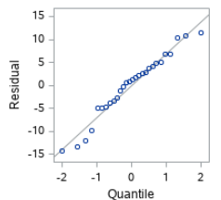
    - This is basically linear. Given some outliers on the end and start
  - Boxplot
    - 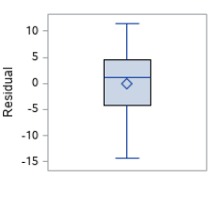
    - Given Box plot no outlier catching us eyes

- Should you use this regression equation, if so, what is the regression equation?
  - The model is mainly reliable and can be utilized because the residual is IID, but it is not very reliable because the R2 is not large enough. The following is the regression equation:

Final_Grade = 0.54591 * Final_Exam + 43.69879
  - Predict final grade based on class work
PROC REG DATA = HW4 PLOTS = DIAGNOSTICS(STATS = NONE);
MODEL Final_Grade = Final_Exam;
RUN;

    - 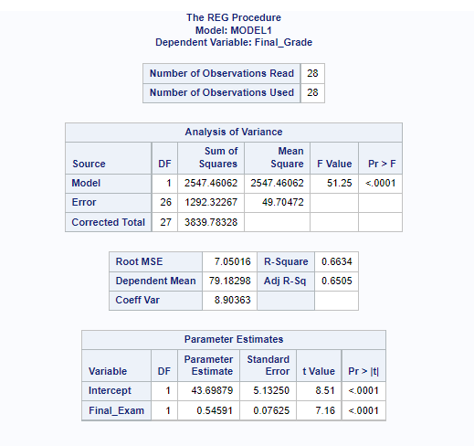
      - P-value of ANOVA table
        - The P-value of ANOVA table is < 0.0001.
      - Under the condition of the 95% confident interval, P-value < 0.0001 means the differences between the variances of the means are statistically significant. Model looks good
      - P-value of the slope and intercept
        - The P-value of slope is < 0.0001,
        - The P-value of intercept is <0.0001.
      - Under the condition of the 95% confident interval, which means our independent variable and the intercept is statistically significant, we reject the null that the slope is 0. Also, we reject the null that the intercept is 0. Therefore, we can say the class work variable plays an important role in the linear regression model when predicting the final grade.
      - 3. R2 value
        - R^2 is 0.5084
        - The coefficient of determination (R2) expresses how much variance in one variable can be explained by the variance in another. The R2 value is 0.5084, indicating that the x variable explains 50.84 percent of the variation in the y variable (final grade) (class work). This R2 value indicates the model's utility; it fits the requirement, but not very well. This poses a 50 percent of not fitting

      - Residual Analysis
        - Fit vs Residuals
        - 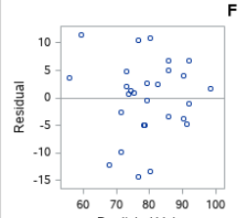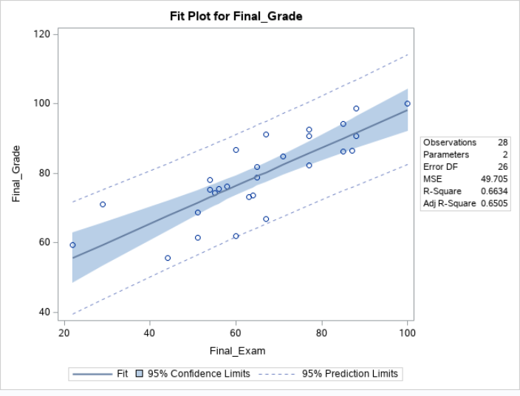
          - The plot shows that there is no telescoping and that the residual distribution is symmetrically centered on zero. This indicates that the standard deviation of the residuals is constant. Also, because there is no discernible patterning, we can infer the residual's independence. The model is then acceptable.
        - Probability Plot
          - 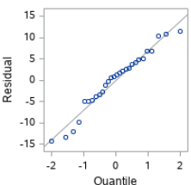
          - The plot of residuals looks basically linear
        - Boxplot
          - 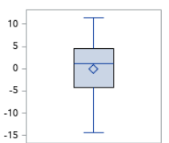
          - we find that there is no outlier.

    - Should you use this regression equation, if so, what is the regression equation?
    - The model is mainly reliable and can be utilized, however it is not particularly dependable because the R2 is not large enough. The following is the regression equation:
      - 0.24299 * Class Work + 61.19508 = Final Grade

- Do a Regression analysis predicting Test_2 based on Test_1.

PROC REG DATA = Homework4_2 PLOTS = DIAGNOSTICS(STATS = NONE);
MODEL Test_2 = Test_1;
RUN;

- P value
  - The P-value of ANOVA table is < 0.0001.
  - Under the condition of the 95% confident interval, P-value is less than 0.0001 means the differences between the variances of the means are statistically significant. That is to say, using the linear regression is reasonable and our model looks good here.
B. P-value of the slope and intercept
a. The P-value of slope is < 0.0001,
b.The P-value of intercept is 0.9846.
c. Therefore, we can say the test_1 variable plays an important role in the linear regression model when predicting the test_2.
c. R^2 value
a. The R2 value is 0.3023.
b. This means only 30.23% of variation of y variable (test_2) is explained by x variable (test_1). This R2 value pointing that the model is not good.
d. Residual Analysis
1. Fit and Residual
The plot shows that there is no telescoping and that the residual distribution is symmetrically centered on zero. This indicates that the standard deviation of the residuals is constant. Also, because there is no discernible patterning, we can infer the residual's independence. The model is then acceptable.
2. Probability Plot
The plot of residuals looks basically linear
3. Box plot
No outlier

Should you use this regression equation, if so, what is the regression equation?
We should not apply this model since, despite meeting the assumptions, the low R2 indicates that it is not dependable or relevant.

